Mr John Donnelly
Headteacher

Crieff High School
Strathearn Community Campus
Pittenzie Road CRIEFF PH7 3JN

Tel 01764 657600 Fax 01764 652842
Email crieffhigh@pkc.gov.uk

Contact Mr J Donnelly

Ref JD/DP

Date 10 June 2020

To Parents and Carers

Crieff High School will re-open to pupils on Tuesday 11th August.

I hope and trust that this finds you all well. Please see below an update as of today:

Planning for the re-opening of Crieff High School

The national approach to the re-opening of schools is one where a blended learning approach will be taken, where part-time in-school learning will be supported by at-home on-line learning.

Earlier this week I shared with our Parent Council the 8 principles and priorities that have underpinned our decision-making when we have been considering how we plan to re-open.

Please see these below:
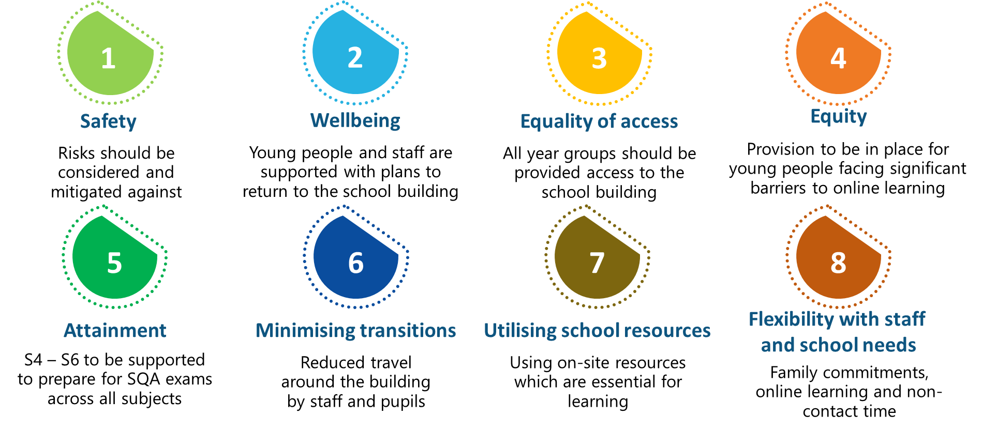

Cont/d
Page 2

10th June 2020

Parents/Carers of
Crieff High School

Planning for the re-opening of Crieff High School (continued)

At a later date, I will communicate the finalised plans and arrangements for August onwards.

In the meantime, please see below that I trust will provide you with reassurance that our young people will be safe at school, where they will continue to thrive in a positive learning environment.

Safety – Enhanced hygiene measures will be in place and physical distancing guidance will be adhered to. Classrooms are being redesigned and non-classroom areas are being modified to become learning areas to ensure young people can adhere to the guidance.

Wellbeing – We know that there is likely to be anxiety and apprehension about returning to school. We are investigating ways in which we can discuss these directly with young people before they return to school and when they do return to school.

Please encourage young people to continue checking Show My Homework (Satchel One) for a future year group Microsoft Team discussion.

Equality of access – We believe that the education of all young people is of equal importance and we are planning on the basis of young people returning to school 2 days a week:

Monday S4 – S6 Tuesday S1 and S3 Wednesday S4 – S6
Thursday S1 and S2 Friday S2 and S3

Equity – During school closure we have become aware that some young people have experienced greater barriers to learning than others and we are creating provision to support this group of young people. Support for Pupils colleagues may be in contact with you directly regarding this.

If you are in a family where the adults of the household are category 1 keyworkers and your young person attending school more frequently than 2 days a week would support your attendance at work then please get in contact with us at CrieffHigh@pkc.gov.uk.

Please provide us with the names of the adults within your household, your role as a keyworker and the names of the young people from your family attending Crieff High School. We will look to support you to attend your critical work as best we can.

Attainment – We recognise that young people who are due to complete SQA qualifications this year are in a different position than is usually the case. The timetable that young people follow when the school re-opens will be different to their current timetable and we will endeavour to provide as much access to their class teachers as possible.

Cont/d
Page 3

10th June 2020

Parents/Carers of
Crieff High School

Planning for the re-opening of Crieff High School (continued)

Minimising transitions – One approach to infection control is to reduce unnecessary travel around the school building. Therefore, when young people attend school they will very likely be asked to remain in one learning area for double periods at a time.

This provides our senior pupils with opportunities to deepen their learning with support from their class teachers. For other year groups, it may be the case that the class teacher rotates from one learning area to another to minimise the number of people moving around the building.

Where possible, young people should be strongly encouraged to bring snack food for intervals and a packed lunch for lunch. They will be allowed to eat these in their learning areas and will not be permitted to leave the school premises during intervals or lunchtime.

This is an important measure to reduce any unnecessary contact with people from out with the school setting.

Utilising school resources – We want young people to experience the benefit of the resources we have at school when they are at school and we have asked our class teachers to plan on this basis.

Flexibility with staff and school needs – I am aware that some of our staff have childcare considerations and/or underlying health issues which may limit their attendance at their place of work. I am working closely with all of our staff to ensure that we take this into consideration.

I hope that the details above provide you with the opportunity to plan for Crieff High School re-opening to young people on Tuesday 11th August.

If there is anything we can do, then do please get in contact with us.

As always, please continue to take care of yourself and your loved ones. Kindest wishes.

John Donnelly

Mr J Donnelly
Headteacher/Campus Leader

