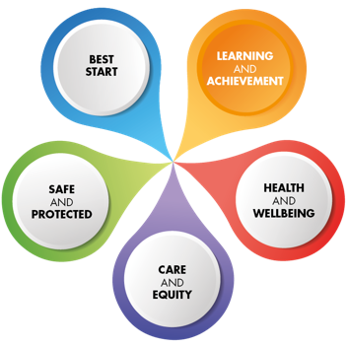­



**Crieff High School**

**Senior Ph****ase (S4-S6)**

**Handbook**

**Session 2023 – 2024**

**Information for Parents/Carers and Pupil**

|  |  |  |  |
| --- | --- | --- | --- |
| Department | Principal Teacher | National Qualifications | Enrichment / Wider Achievement |
| [Art and Design](https://blogs.glowscotland.org.uk/pk/crieffhighschool/coursechoice-design/) | Miss M Johnstone | Art & Design  Drawing Skills  H Photography (PC) | NPA Digital Photography  Scottish Studies  Art & Design – printmaking & illustration |
| [CDT](https://blogs.glowscotland.org.uk/pk/crieffhighschool/coursechoice-design/) | Mrs L Birrell | H Design & Manufacture  Engineering Science  Graphic Communication | Practical Electronics  Practical Woodwork |
| [Business and Computing](https://blogs.glowscotland.org.uk/pk/crieffhighschool/coursechoice-digital-learning/) | Mr S Barlow | Administration & IT  Business Management  Computing Science  FA Financial Services (PC) | NPA Games Development  WA Cyber Security  NPA Digital Media |
| [English, Literacy and Drama](https://blogs.glowscotland.org.uk/pk/crieffhighschool/coursechoice-english-drama-literacy) | Mrs K Russell | English | WA Analysing Digital Media  WA Creative Writing |
| [Home Economics](https://blogs.glowscotland.org.uk/pk/crieffhighschool/coursechoice-healthandwellbeing) | Miss S McCully | Practical Cookery  Health and Food Technology  Early Learning and Childcare  FA Social Service – Children & Young people (PC) | Survival Cookery S5 and S6 only  NPA Bakery  Health Studies (PC) |
| [Mathematics](https://blogs.glowscotland.org.uk/pk/crieffhighschool/coursechoice-mathematics) | Mrs J Knak | Application of Mathematics  Mathematics | WA Personal Finance |
| [Modern Languages](https://blogs.glowscotland.org.uk/pk/crieffhighschool/coursechoice-modern-languages) | Mrs L Yates | French  Spanish | WA Modern Languages Award |
| [Music](https://blogs.glowscotland.org.uk/pk/crieffhighschool/coursechoice-music) & Drama | Mr D Griffiths | Music  Drama  Creative Industries  Music Technology | NPA Musical Theatre |
| [Physical Education](https://blogs.glowscotland.org.uk/pk/crieffhighschool/coursechoice-healthandwellbeing) & HWB | Mr G Aitken | PE  H Psychology  FA Social Services (PC) | NPA NPLQ level 6  NPA Sport & Fitness  NPA Beauty Skills (PC)  WA Mental Health & Wellbeing |
| [Religious and Moral Education](https://blogs.glowscotland.org.uk/pk/crieffhighschool/coursechoice-religious-and-moral-education) | Mrs J Petrie | N5 Classical Studies  RMPS | WA Mythologies  WA Events Planning S6 |
| [Science](https://blogs.glowscotland.org.uk/pk/crieffhighschool/coursechoice-science) | Mrs L Potter | Biology  Chemistry  Physics | NPA Laboratory Science  WA Young STEM leader  NPA Science & Health |
| [Social Subjects](https://blogs.glowscotland.org.uk/pk/crieffhighschool/coursechoice-social-subjects-3) | Miss M Logan  Mr D Faunce-Smith | Geography  History  Modern Studies  Politics  Sociology  People and Society | WA Politics  WA Criminology  WA Climate change  Travel & Tourism SfW |
| KEY – NPA – National Progression Award, SfW Skills for Work Award,  PC – Perth College. <https://www.perth.uhi.ac.uk/school-college-partnership/> for more options | | | |

**The SCQF Levels**

### What is the SCQF?

The SCQF is a way of comparing Scottish qualifications to other qualification frameworks. It does this by giving each qualification a **level** and a number of **credit points**.

* The level of a qualification shows how difficult the learning is.
* The credit points show how much learning is involved in achieving that qualification.

It covers achievements from school, college, university, and many work-based qualifications.

Almost all courses we offer fall on the Scottish Qualification Framework which means there is accreditation at the end of the course.

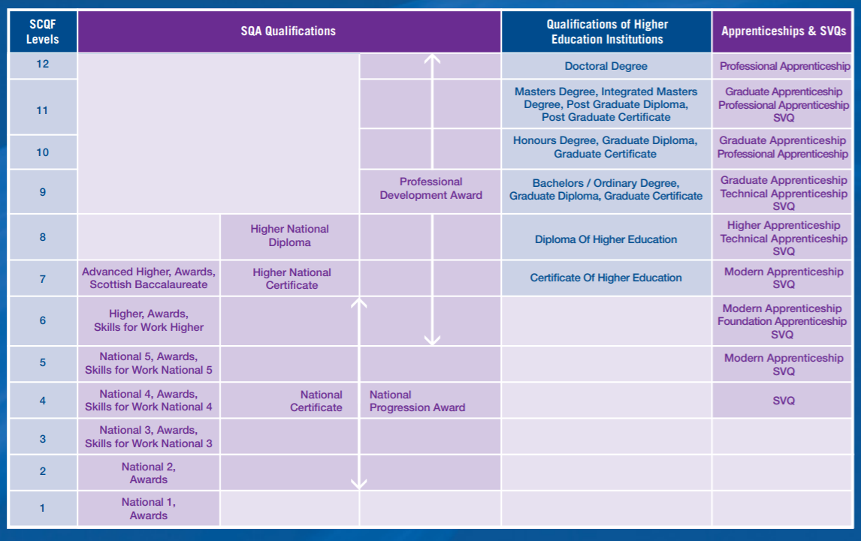

Most young people within the Senior Phase will be working at levels 4, 5 6 or 7. These is support for those who are working at levels 1 2 and 3.

The National Parent Forum has an excellent range of in a nutshell guides which go into detail on various subjects and National 1, 2 and 3 <https://www.npfs.org.uk/>

What is a National Progression Award (NPAs)?

National Progression Awards (NPAs) are available in a variety of sectors, from Construction and Childcare to areas such as Digital Literacy and Social Software.

They're aimed at assessing a defined set of skills and knowledge in specialist vocational areas. They also link to National Occupational Standards, which are the basis of SVQs.

NPAs are at SCQF Levels 2-6 and are delivered in partnership between schools, colleges and employers. Although many schools get involved, they’re mainly used by colleges for short-study programmes, such as return-to-work courses.

An example of an NPA is Cyber Security (SCQF Levels 4-6). The NPAs in Cyber Security at SCQF levels 4, 5 and 6 provide foundation knowledge and skills in data security, digital forensics and ethical hacking — and provide a skills pipeline into the cyber security industry.

The timetable structure allows students to take a selection of different levels of qualification allowing for a fully personalised timetable. NPAs are 4 periods per week.

**What is a Wider Achievement option?**

Wider Achievement options are two period per week course options which are designed to create a rich and diverse timetable. Students who complete a Wider Achievement option will gain typically one unit of a full qualification minimum which building their skills, knowledge and understanding of a wide range of topics.

**What is National 4?**

National 4 (SCQF level 4) Learners taking National 4 Courses and Units may have progressed from the experiences and outcomes at curriculum level 3 in the broad, general education in S1–S3, or from SQA qualifications at SCQF level 3. National 4 Courses and Units are designed to enable learners to develop skills, knowledge and understanding in a specific subject area, as well as skills for learning, skills for life and skills for work. A National 4 Course has 24 SCQF credit points. To achieve a National 4 Course, it is necessary to achieve the units in the course — this includes the Added Value Unit which has 6 SCQF credit points. The Added Value Unit selects from one or more of the other units in the course and is internally assessed in centres as a pass or a fail. There is no external assessment in National 4 Courses. Learners who achieve National 4 Courses and Units may progress to National 5 Courses, or to other SQA qualifications at SCQF level 5. Some learners will exit secondary education with National 4 Courses and progress to further education, training or employment.

**What is National 5?**

National5 (SCQF level 5) Learners taking National 5 Courses may have progressed from SQA qualifications at SCQF level 4 or from the experiences and outcomes at curriculum level 4. National 5 Courses are designed to enable learners to develop skills, knowledge and understanding in a specific subject area, as well as skills for learning, skills for life and skills for work. A National 5 Course has 24 SCQF credit points. To achieve a National 5 Course, it is necessary to achieve the course assessment. The course assessment samples from across the course content and will often be a question paper and another assessment method such as an assignment. National 5 Courses are graded A–D. The grade for the course is based on the learner’s performance across the course assessment. Learners who achieve National 5 Courses may progress to Higher Courses, or to other SQA qualifications at SCQF level 6. Some learners will exit secondary education with National 5 Courses and progress to further education, training or employment.

**What is Higher?**

Higher (SCQF level 6) Learners taking Higher Courses may have progressed from SQA qualifications at SCQF level 5. Higher courses are designed to enable learners to develop more complex and challenging skills, knowledge and understanding in a specific subject area, as well as higher-order skills for learning, skills for life and skills for work. A Higher course has 24 SCQF credit points. To achieve a Higher course, it is necessary to achieve the course assessment. The course assessment samples across the course content and will often be a question paper and another assessment method such as a project. Higher courses are graded A–D. The grade for the course is based on the learner’s performance across the course assessment. Design of National Courses and Units 10 Learners who achieve Higher courses may progress to Advanced Higher courses, or to other SQA qualifications at SCQF level 7. Some learners will exit secondary education with Higher courses and progress to further/higher education, training or employment. Highers are the standard entry requirements for higher education in Scotland.

What is Advanced Higher (S6 only)

Advanced Higher (SCQF level 7) Learners taking Advanced Higher courses are likely to have progressed from SQA qualifications at SCQF level 6. Advanced Higher courses are designed to enable learners to develop more complex and challenging skills, knowledge and understanding in a specific subject area, as well as higher order skills for learning, skills for life and skills for work. An Advanced Higher course has 32 SCQF credit points. This reflects the greater amount of responsibility that learners will have for their own learning, and also the greater proportion of the course that they will work on independently and with less supervision. To achieve an Advanced Higher course, it is necessary to achieve the course assessment. The course assessment samples from across the course content and will often be a question paper and another assessment method such as a project. Advanced Higher courses are graded A–D. The grade for the course is based on the learner’s performance across the course assessment.

**Senior Phase Course Choice Booklet**

# Introduction

This booklet is designed to give you, pupils and parents/carers, information about the Senior Phase of Curriculum for Excellence and is designed to help you make sensible choices about courses to be studied. Please read it carefully and, where necessary, seek further information and advice from relevant staff including subject specialists and personal support teachers.

# Curriculum Levels

There are national levels to describe different stages of learning and progress. For most children the expectation is:

|  |  |
| --- | --- |
| Early Level | Pre-school to the end of P1 |
| First Level | To the end of P4 |
| Second Level | To the end of P7 |
| Third and Fourth Levels | S1 – S3, with the fourth level broadly equivalent to the SCQF framework (see abbreviations section) |
| Senior Phase: National Qualifications | S4 - S6, and equivalents in other settings, where students can continue to develop the four capacities and achieve qualifications. |

# What is the Broad General Education and Senior Phase?

The term “Broad General Education” describes the time from age 3 to May of S3. During their “BGE” in Crieff High School pupils undergo a wide range of experiences across all eight curricular areas with some personalisation and choice along subject lines.

In May of S3 pupils begin the Senior Phase of their education which continues, with various exit points, to the end of S6. In the Senior Phase students continue to focus on skills for learning, life and work while moving towards national qualifications and their transition to life beyond school.

# How will the Senior Phase be organised in Crieff High School?

The course choice forms are designed to allow as much personalisation and choice as possible and should allow pupils to select those subjects that are likely to offer them the greatest possibility of success.

All pupils will study a core curriculum of Religious and Moral Education, Physical Education, Social Education and Personal Support.

The Support for Pupils Staff have a key role in supporting each pupil in making appropriate choices. You are welcome to contact your child’s Guidance Teacher to discuss any aspect of the choice process.

The Guidance Team comprises Mr Duncan, Mrs Douglas and Mrs Walker. Mrs Fotheringhame and Mrs Prince, the Year Heads, will be overseeing the process and can also be contacted at the school.

Course choice forms should be returned to your child’s Guidance Teacher by the date indicated on the form.

**It should be noted that whilst every effort is made to offer a broad range of subjects no guarantee can be given that every class will run.**

**This will depend on an adequate number of pupils enrolling for the course and staff availability.**

# The Senior Phase Curriculum

The curriculum for pupils in Crieff High School is continually being adapted and developed to help pupils realise their potential and to benefit from developments taking place nationally. Our curriculum is shaped by the need to deliver opportunities for our pupils to develop the following:

**knowledge and understanding skills respect**

**participation community partnership   
achievement opportunity enterprise**

In the senior phase, in response to the growing maturity of the pupils, there is:

* an expectation of high levels of achievement based on previous years’ progress
* more opportunities to become involved in the community
* more opportunities to develop a leadership role in the life of the school
* a framework which continues to direct and support
* in S6 only, a greater degree of responsibility in managing ‘non-contact’ time

It is a distinctive and special feature of school education for young people 16-18 that there is involvement in the wider school community, not just in the classroom. In recognition of this the curriculum in Crieff High School contains

* a compulsory core, involving key aspects of personal and social development
* a choice of personal development activities
* a choice of courses at different levels
* opportunities, as appropriate, for involvement in open learning situations

# The Core Curriculum

All pupils in the senior phase are expected to follow a core curriculum which includes elements of Personal and Social Education (PSE), Physical Education, Religious Education as well as other wider achievement opportunities.

This will provide young people further opportunities to develop as:

**effective contributors successful learners**

**responsible citizens confident individuals**

As part of this programme it is expected that all S5 pupils will complete a CV and personal statement and Guidance staff will continue to play a key role in assisting pupils to realise their potential. Guidance Teachers will continue to work with pupils on their personal statement which recognises personal goals and achievements as well as academic ones.

All S5 pupils will take part in a mock interview. They will also attend the ‘Safe Drive/Stay Alive’ presentation in Perth.

All S6 pupils are expected to take part in Holocaust Studies

# Making your choice

Young people aged 15, 16 or 17 often have a variety of aims and ideas as to what they wish to do in school and beyond. Some of this will be dictated by entry qualifications for college or university courses .... but this is not the whole story.

One of the first essentials for success in a career or in Higher Education is that the young person has personal skills such as – adaptability, good teamwork, perseverance, good work and study habits, consideration and punctuality. On its own a narrow classroom-based curriculum cannot deliver these qualities – they come from participating in the school and its community. To assist with ensuring an appropriate balance in choice, the school operates the following structure:

For the majority of those returning to school at the end of S4, course choices should be considered as a two-year experience.

**For S4 Pupils**

In S4 pupils will normally be able to choose seven subjects.

In S4 pupils will study at either National Qualifications (levels 3-5) or National Progression Awards or Wider Achievement Awards. National Four is broadly comparable to Standard Grade General Level and Intermediate 1 while National Five is broadly comparable to Standard Grade Credit Level and Intermediate 2.

**For S5 Pupils**

S5 students will be expected to follow a full curriculum – this means choosing at least 5 subjects. By negotiation with their Guidance Teacher, and subject to the approval of the Headteacher, a young person may wish for a particular aspect of agreed community or school service to be undertaken during the term. Some S5 pupils, particularly those who intend to leave at Christmas of S5, may negotiate a community placement or extended work placement for part of the time, subject to the approval of the Year Head.

In making up the full week, students should pay close attention to the advice given by Guidance, Subject Teachers and their Year Head.

**For S6 Pupils**

S6 students will choose 5 subjects. Those students taking Advanced Higher courses may negotiate additional study time in the Department involved or the opportunity to study elsewhere in the school. Developing good habits of time management and commitment to private study is one of the requirements of success in Advanced Higher courses.

All time not allocated to classes must be committed on the option form or on their timetable.

# Winter Leaver Options

**Are you a winter leaver?**

If you are 16 between 1 March and 30 September 2023 you can leave school after 31 May 2023. However, you are a winter leaver if you are 16 between 1 October 2023 and the last day of February 2024. If your 16th birthday falls between these dates you cannot leave school until the start of the 2023 Christmas holidays.

If you are a winter leaver you can choose to stay on at school or you can consider one of the options below.

**Full-time Courses at Perth College**

If you know that you would like to continue your learning at Perth College, and know the subject you would like to study, the college will accept applications for full-time courses starting in August 2023. These courses run beyond Christmas 2023.

**Next Steps 2 Learning at Perth College**

If you know you would like to continue your learning at Perth College but are unsure of what route to follow, Perth College offers the Next Steps 2 Learning course for people who have either just left school, or have been unemployed for a while, or are winter leavers. This course allows you to try out a variety of different areas within the College – from Construction to Childcare, Horticulture to Hospitality and Music to Motor Vehicle. You will also study core skills in IT, Numeracy and Communication, as well as develop a better understanding of the demands and responsibilities of preparing for either further study or possible work opportunities. You will also have the opportunity to go on work experience in an area you are interested in.

**Directions**

If you are you unsure whether your next step should be employment or college then Directions may be the right choice for you. Running from August to December, it offers you the opportunity to take your next steps through a variety of qualifications and experiences. For example, you will participate in a team building residential, learn coaching skills, study for a first-aid certificate, run a small business enterprise project; and work on life skills such as cooking, handling your money and job searching. A work placement will also be part of this course. After Directions you will be supported into your next steps in January: options then include Get Ready for Work, a modern apprenticeship or other training, or employment. If you are not ready for one of these, an Activity Agreement may be a good next step. An Activity Agreement is a personalised programme that builds employability and personal skills: a good example is the LINC programme.

**For more details about these options including how you apply, contact your guidance teacher or our careers adviser Kirsten Mair.**

|  |  |
| --- | --- |
|  |  |
| [Learner Journey](https://blogs.glowscotland.org.uk/pk/public/crieffhighschool/uploads/sites/6592/2021/02/02100518/Learner-Journey-in-a-Nutshell.pdf) | [Senior Phase](https://blogs.glowscotland.org.uk/pk/public/crieffhighschool/uploads/sites/6592/2021/02/02100529/Senior-Phase-in-a-Nutshell.pdf) |
|  | |
| [Progression in the Senior Phase](https://blogs.glowscotland.org.uk/pk/public/crieffhighschool/uploads/sites/6592/2021/02/02100523/Nutshells-Progression.pdf) | |
|  | |
| [Wider Achievement](https://blogs.glowscotland.org.uk/pk/public/crieffhighschool/uploads/sites/6592/2021/02/02100532/Wider-Achievement.pdf) | |